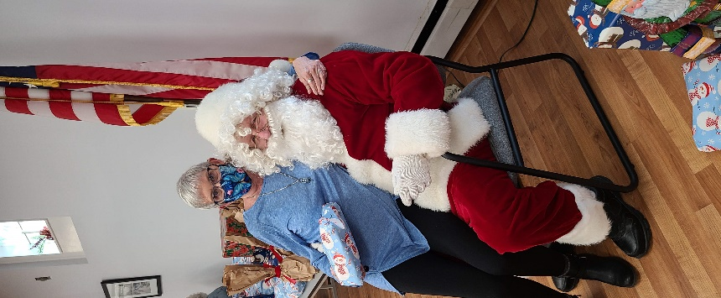

**Programs and Activities to Look Forward to:**

1. **Bag BINGO** returns Saturday afternoon, February 26 at the Kimberton Fire Company. Save the Date! More information to come. [Click Here](https://app.etapestry.com/onlineforms/SeniorAdultActivityCenterofth/BINGO.html) for tickets.
2. **Valentine 50/50 tickets** are available. One for $10, 3 for $25. Winner will be pulled at the Third Thursday Valentine’s Dance on February 17. These would make great stocking stuffers for the loves of your life. Call 610-935-1515.
3. **Vaccine Clinics** with Chester County Health Dept. will be held on Tues. Jan. 18th an 25th. Call if you need help registering. To register yourself, [click here](https://chescohealth.as.me/schedule.php).
4. **January Third Thursday – January 20** Mystery Night at the Center. Help us solve the mystery!
5. **February Third Thursday – February 17** Dinner and a DJ 5-7 Spaghetti Dinner and Dancing $10

See you at the Center!

Its Christmas week, and Covid is emerging as a problem again the year. There is major spread in Pennsylvania due to the Delta and Omicron variants, even among the vaccinated. Because so many of our participants are vaccinated and boosted, for now, we are remaining open. But, we will delay the opening of the kitchen and continue the food drive thru for the month of January. It was scheduled to end at the end of the year. For the safety and consideration of yourself and other, please STAY HOME if you are not feeling great. You may think you are just tired or have the sniffles, but it may be much more. Wear a mask anytime you are around others, and weigh your risk before going anywhere. At the Center, reservations are required for all activities by calling 610-935-1515 x 29 or email [christine@phoenixvilleseniorcenter.org](mailto:christine@phoenixvilleseniorcenter.org). Please leave your name and what activity you plan to attend on the answering service, no need to speak to a person directly, Masks are required. Click [HERE](https://us02web.zoom.us/j/3507193523?pwd=VXpheTA0RENDTTJacFlWUXdRUHU5dz09) for PASC Zoom classroom for on line activities. 

What a wonderful time of the year! The holidays bring us together like no other season. This week at the Senior Center was like a Hallmark movie. The decorations were perfect, the food was delicious, the cookies were works of art, the music and singing were breathtaking, Santa was generous and jolly, and love and friendship were pure and uplifting. Thank you all for your part of this wonderful week, whether as a participant, a volunteer, a donor, or board or staff member. You helped make memories that will last for years! We especially want to Thank Lisa Vorel and her Pianist John, Great Valley Community Organization, Jim Kassel, Foresta’s Market, Johnson & Johnson RDBT, Marti Daly. See pictures below.

THIS WEEK AT THE CENTER

December 20-24

