Mobile Home Tax Reassessment Program
Deadline to apply for 2022 is July 15!
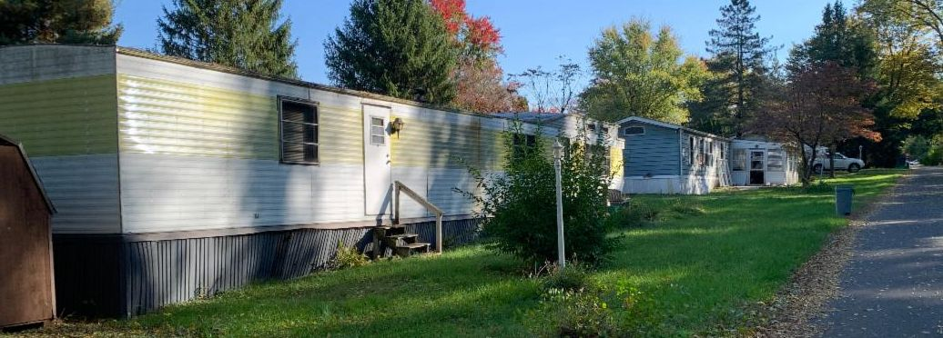

DO YOU OWN A MOBILE HOME ON A RENTED LOT?
United Way of Chester County, along with our partners, is offering assistance to mobile home owners in Chester County to
file for property tax reassessment appeals.
We will do all the work and pay the fees on behalf of the homeowners in the program.

Join us at our upcoming community outreach events for our Mobile Home Tax Reassessment Program on July 21, 2022 5-7 PM Phoenixville Library 183 Second Avenue, Phoenixville, PA 19460
Please bring your title and/or other home documents (insurance documents, bills of sale/receipts if home purchased in 2019 or later). Help will be available in English and Spanish.

To learn more about the Mobile Home Tax Reassessment program or to fill out the 2022 form, click here or contact Darshana Shyamsunder, Senior Director, Community Impact Initiatives, at 610.429.9400 ext. 4112. Deadline to apply is July 15, 2022.

If you are interested in financially supporting this initiative, please contact Doug Kaiser, Director of Resource Development, at 610.429.9400 ext. 4102.

