Pick up your Memorial Day picnic favorites
from the original Uncle B on
May 25, 4-7 PM
and support
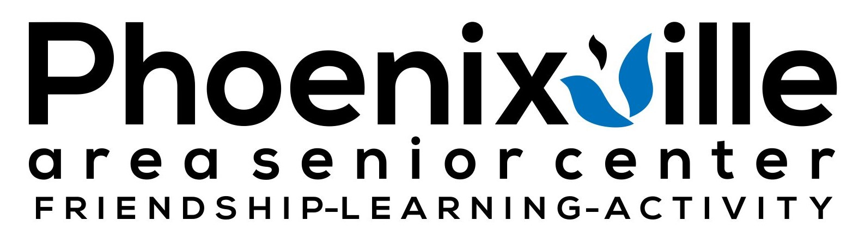

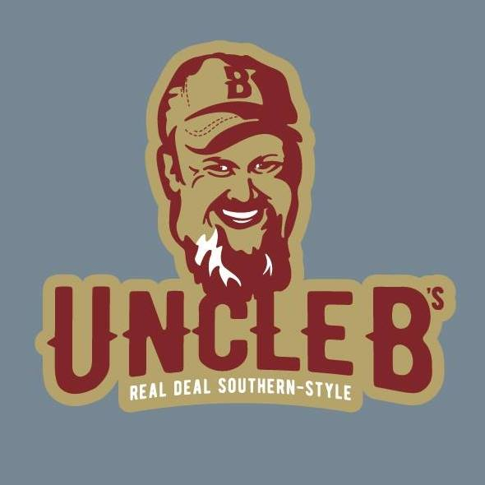

Drive-thru BBQ FUNDRAISER

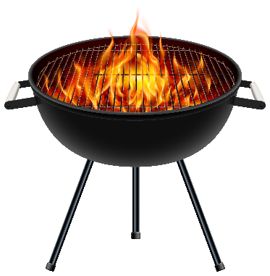

Item | Pint | Quart | 1/2 hotel pan
 | Serves 2-4 | Serves 6-8 | Serves 12-16
Pork | $12 | $24 | $48
Chicken | $12 | $24 | $48
Mac & Cheese | $9 | $18 | $35
Cole Slaw | $7 | $14 | $25
Alabama White Sauce | $6
Kansas City BBQ Sauce | $6
Meat is freshly cooked and not sauced. Can be frozen.
Re-heating instructions provided on package.
To place your order, go to
http://bit.ly/pascBBQ, click here, or
scan the QR code.

